[Ascent -- Project](https://ascent.cysun.org/project/project/view/230)

Using NASA’s ION-DTN to build an email system.

## Why don’t traditional email systems work?

Traditional TCP/IP and SMTP protocols rely on low-latency, uninterrupted networks because they need multiple handshakes to communicate. However, space networks have **high delays** and **frequent disruptions**, making these traditional systems unreliable in such environments.

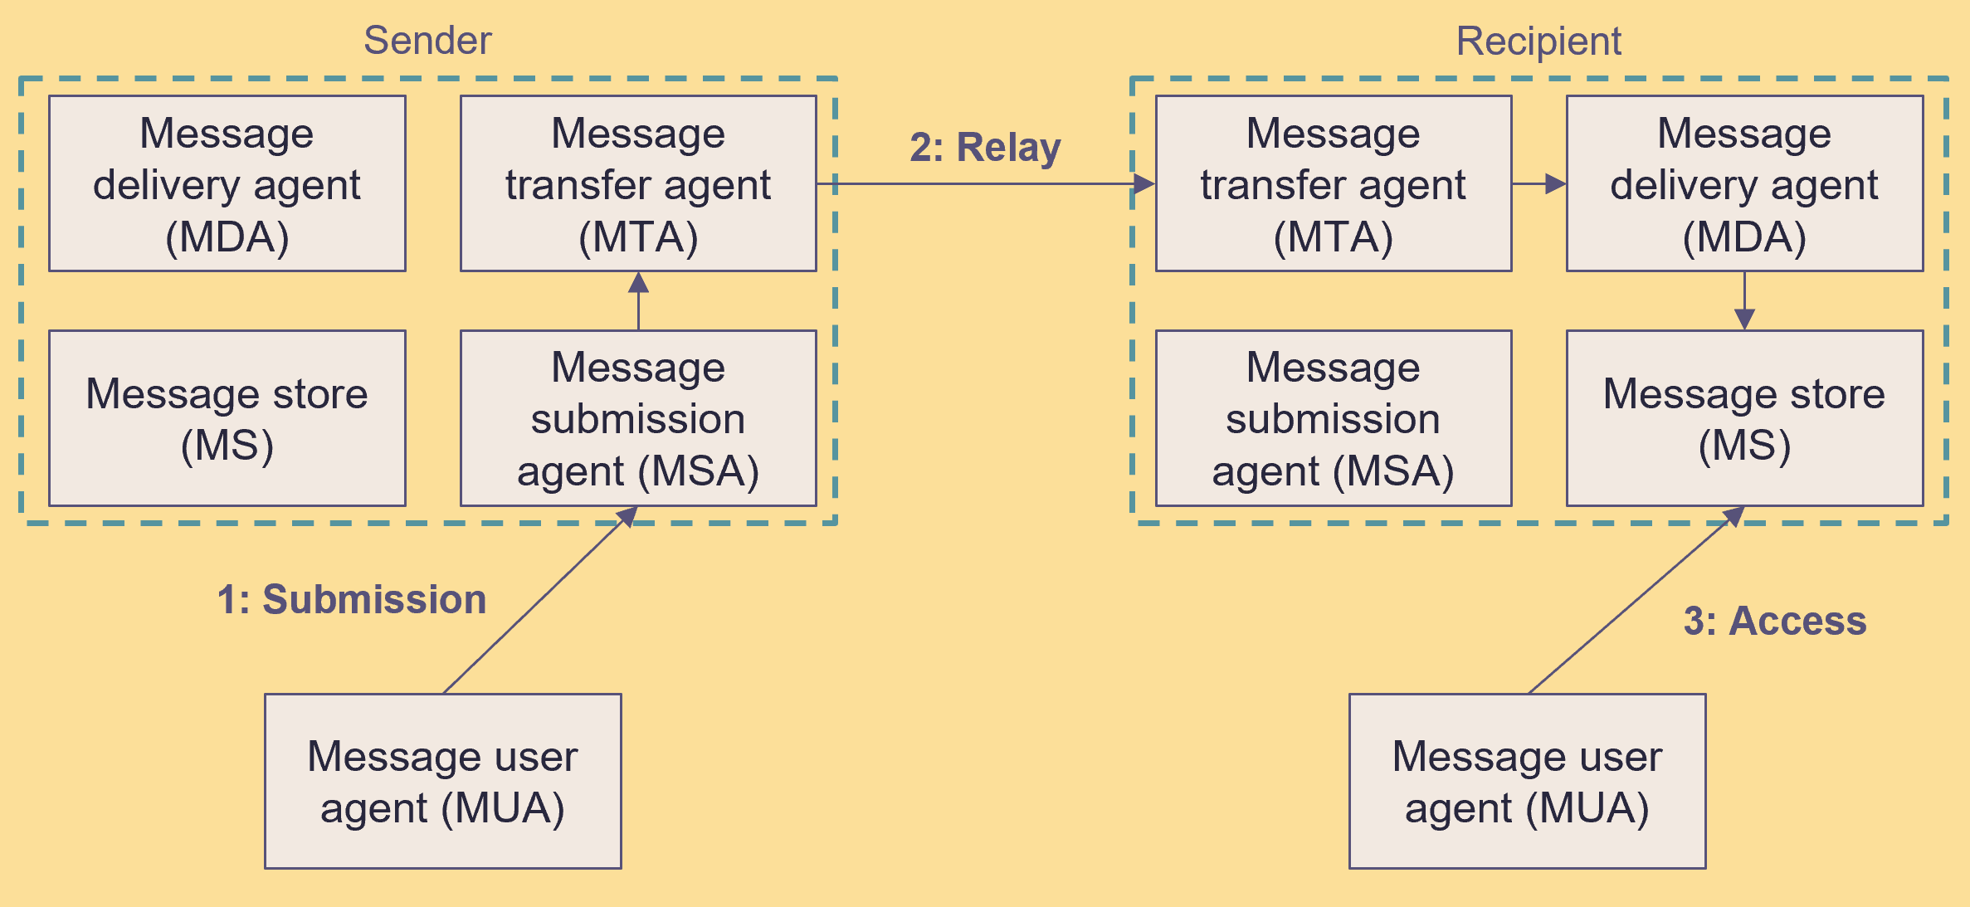

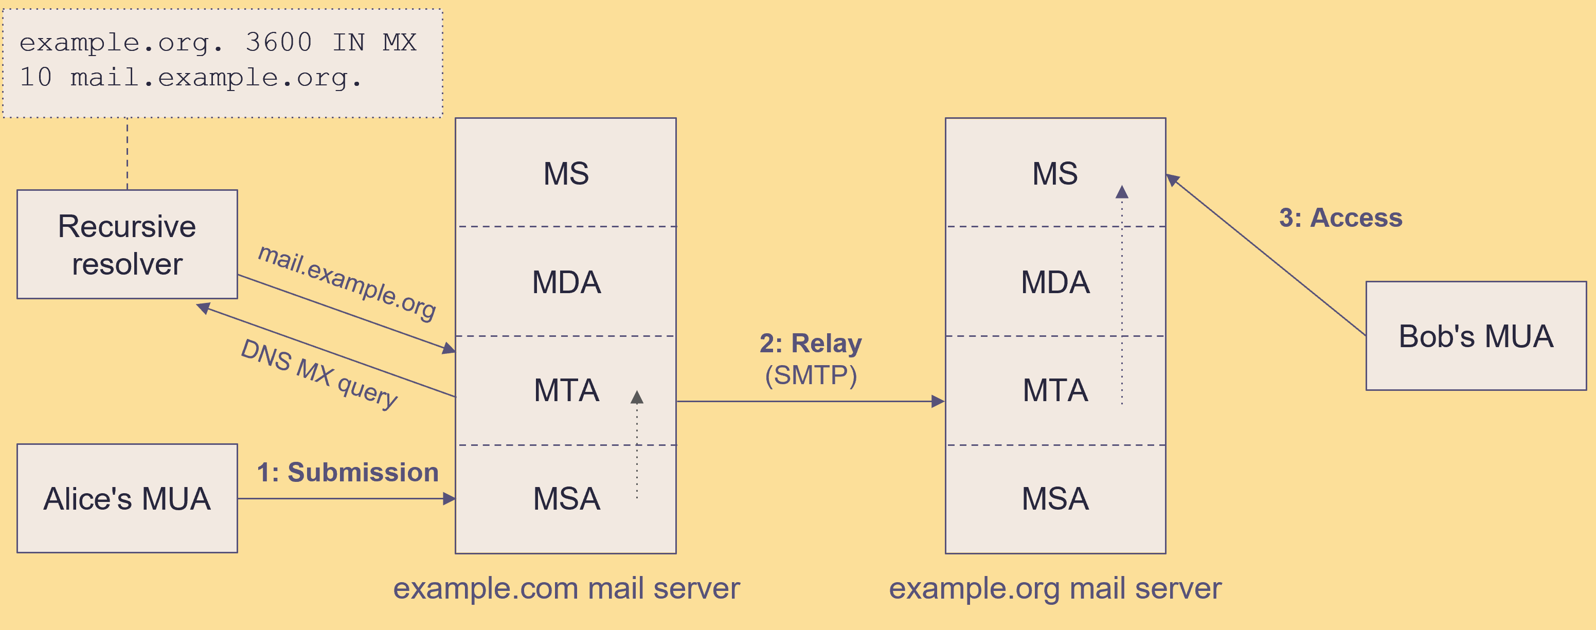

How the email systems work

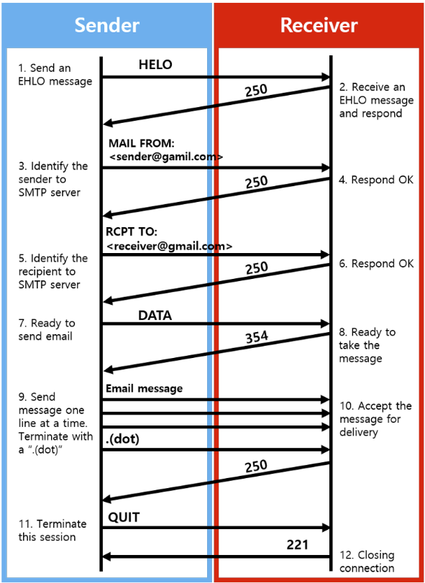

Many Round-Trip in SMTP

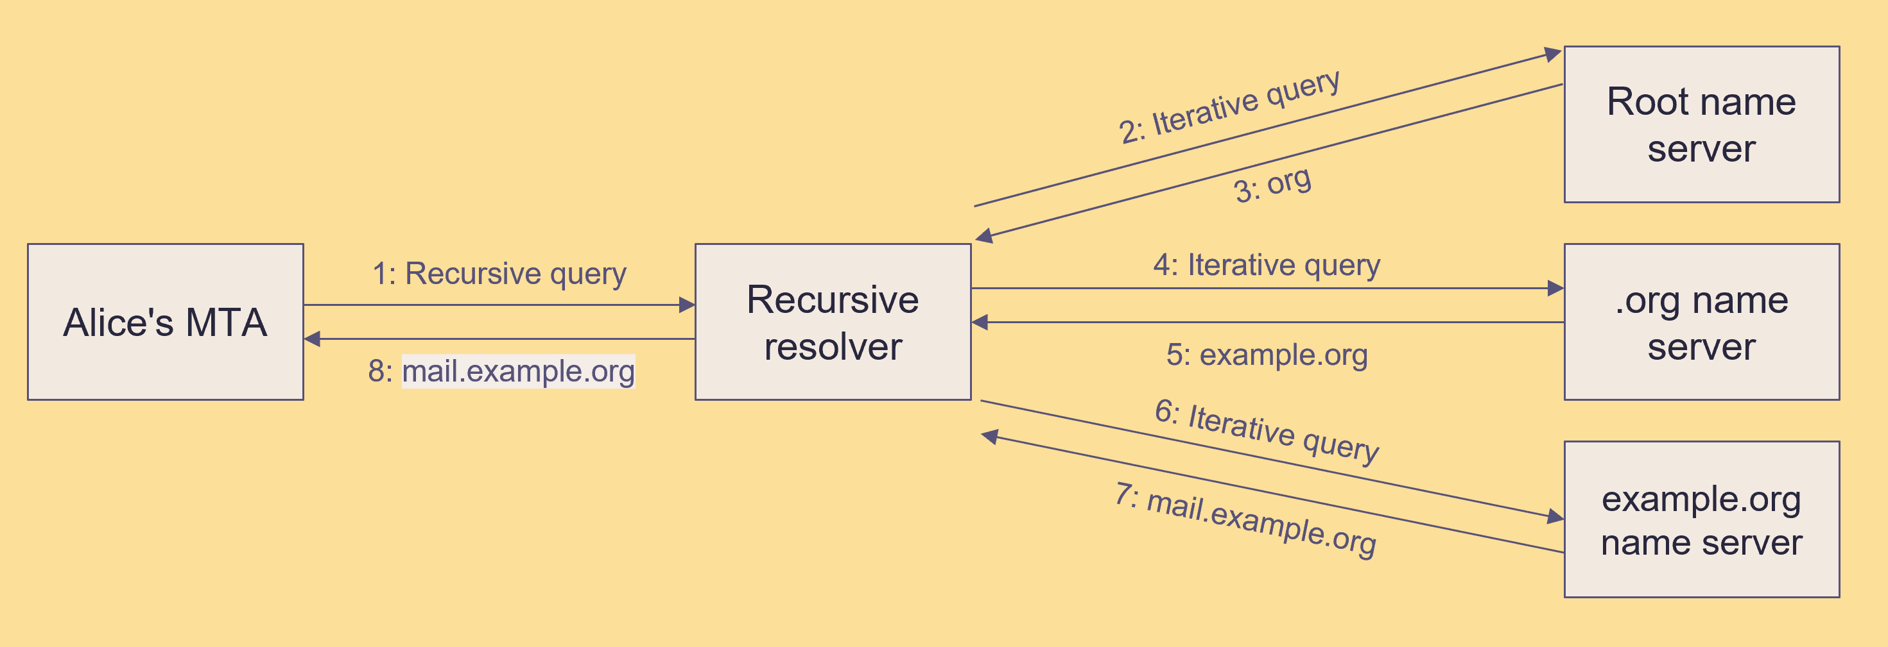

Many Round-Trip in DNS query

## How can we solve the problems caused by space networks?

DTN uses “**store and forward**” technology, which solves the problems of high delay and frequent disruptions.



Store and Forward

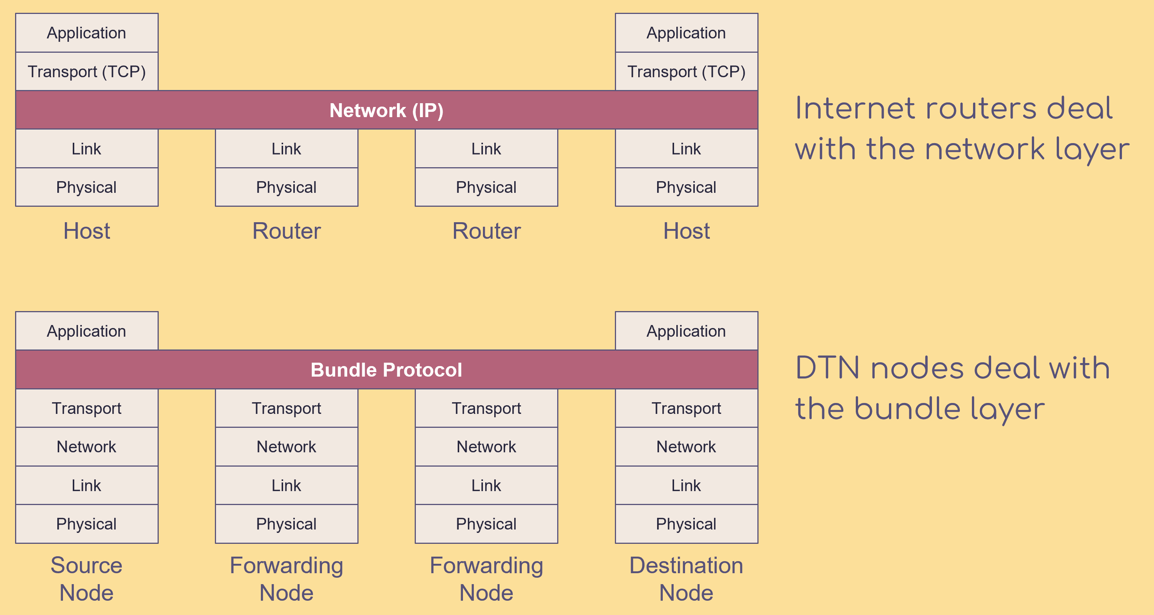

DTN adds a “bundle” layer on top of the transport layer. This bundle layer enables the “store and forward” feature.

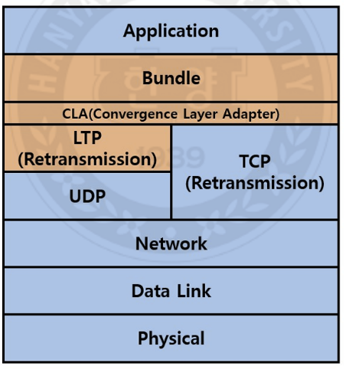

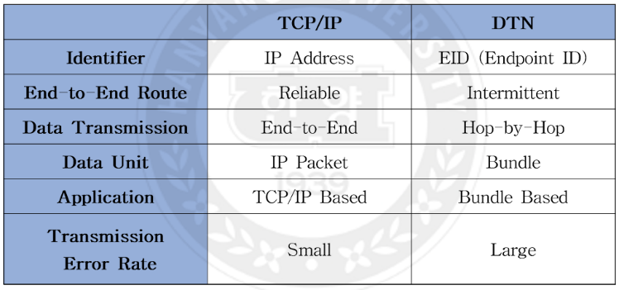

## How to combining the email system with DTN ?

[draft-johnson-dtn-interplanetary-smtp-01 - A method for delivery of SMTP messages over Bundle Protocol networks.](https://datatracker.ietf.org/doc/draft-johnson-dtn-interplanetary-smtp/)

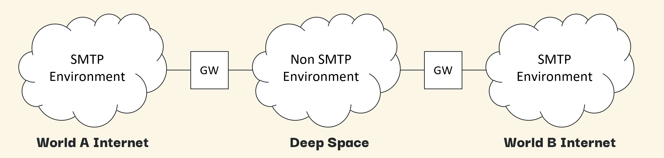

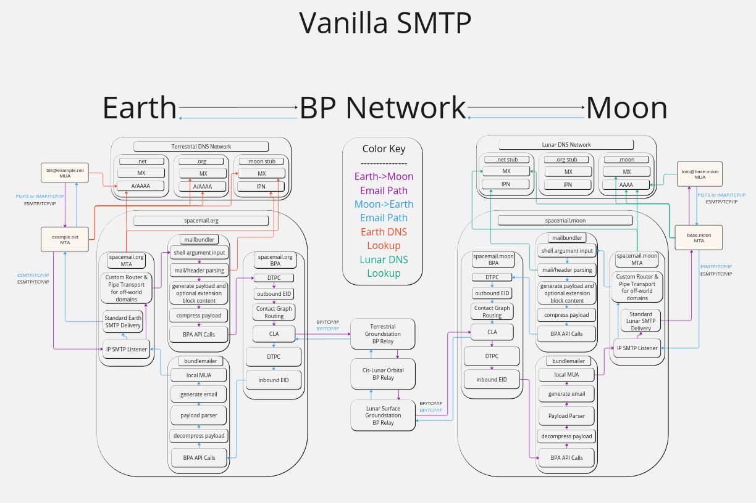

Gateway

[draft-blanchet-dtn-email-over-bp-05 - Encapsulation of Email over Delay-Tolerant Networks(DTN) using the Bundle Protocol](https://datatracker.ietf.org/doc/draft-blanchet-dtn-email-over-bp/)

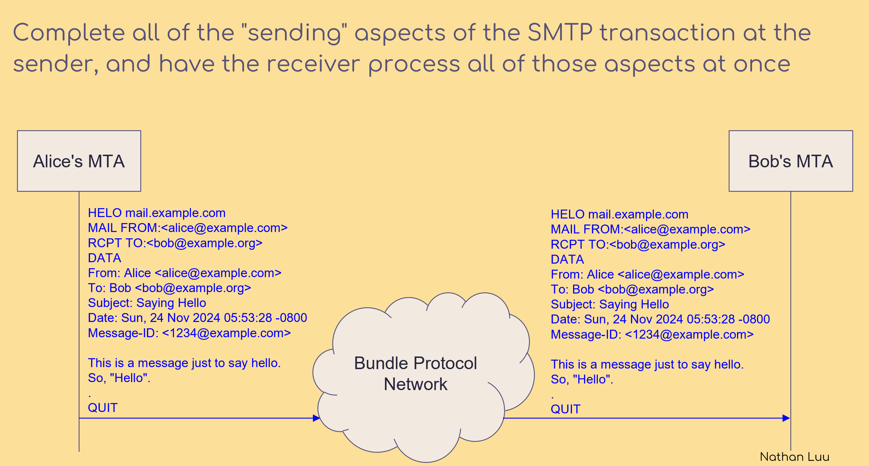

Batch SMTP (Both sides are trusted nodes, so there’s no need for extra handshakes.)

[draft-johnson-dtn-interplanetary-dns-04 - An Interplanetary DNS Model](https://datatracker.ietf.org/doc/draft-johnson-dtn-interplanetary-dns/)

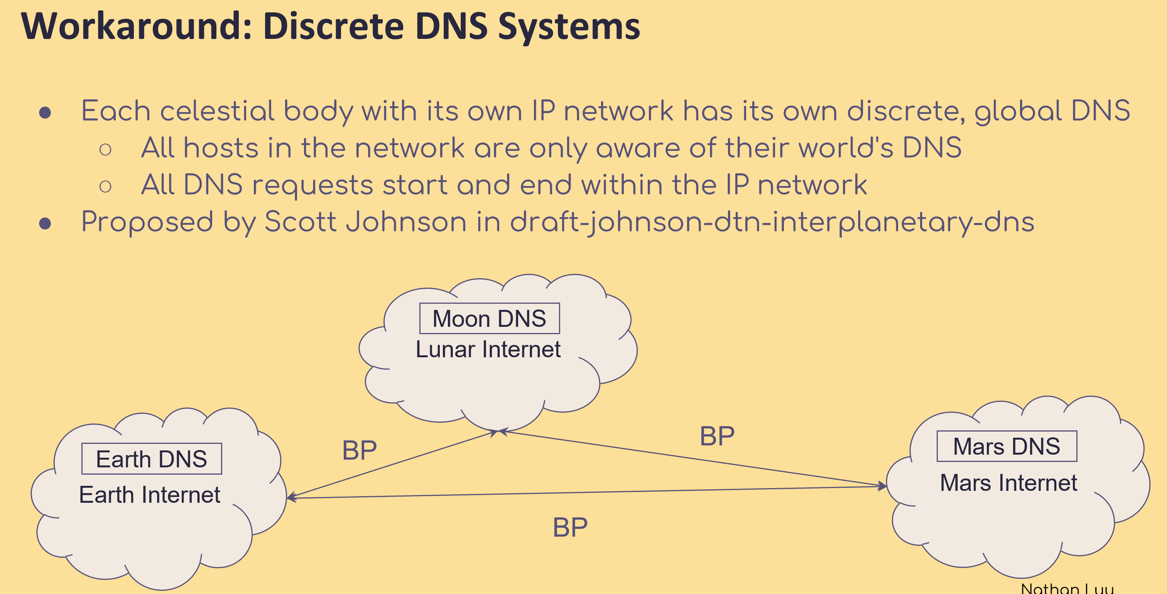

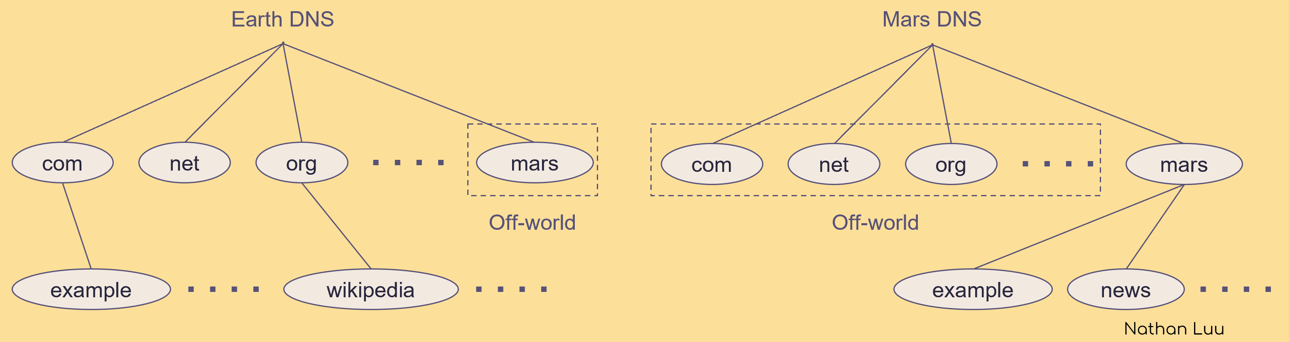

Name servers for off-world domains are not "real". Must be gateways.

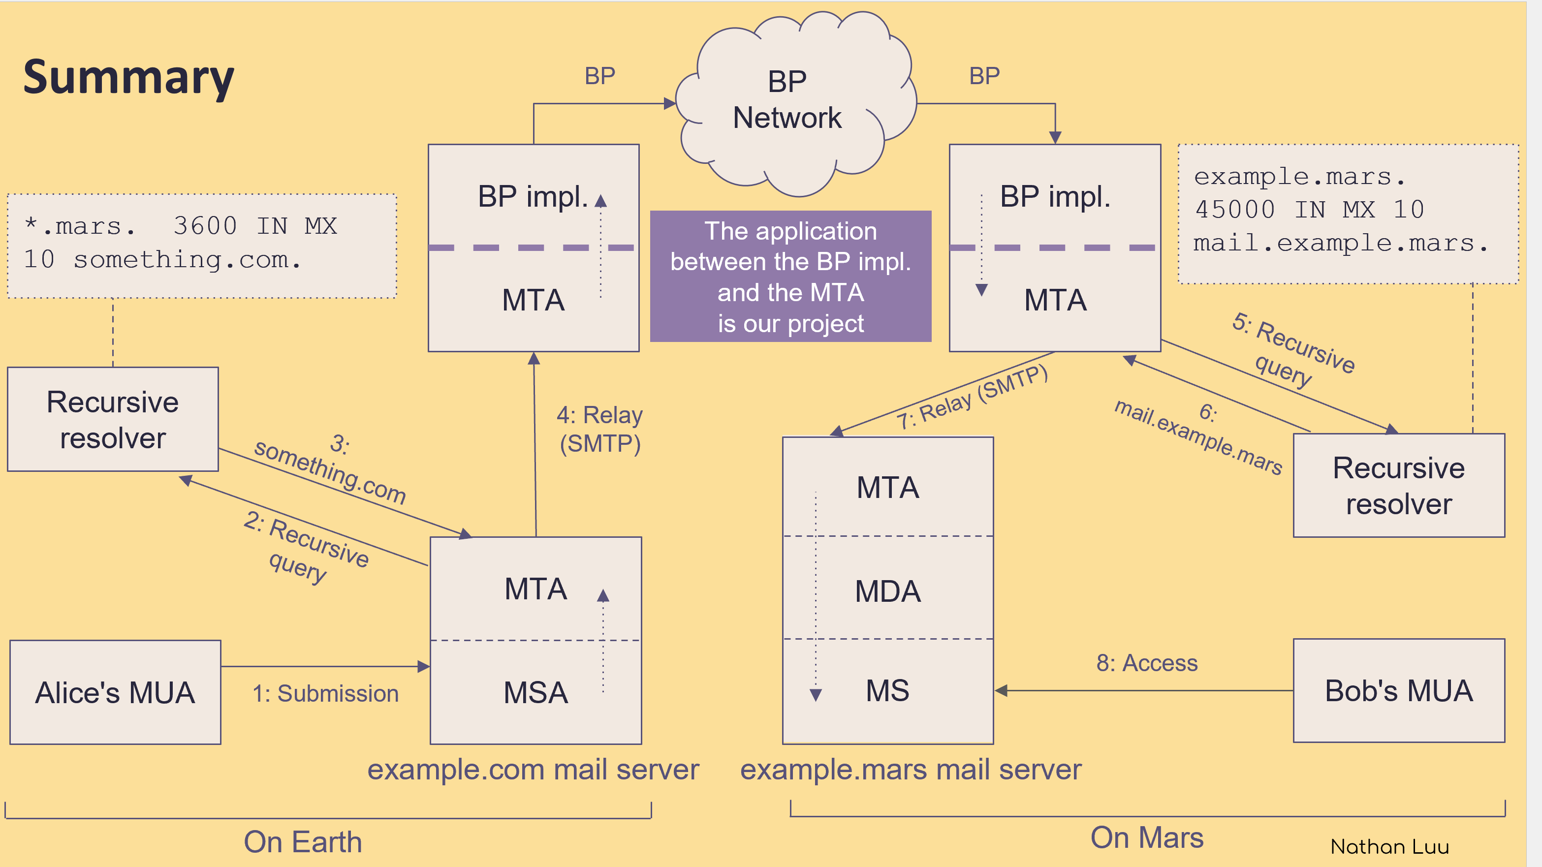

[Ascent -- Project](https://ascent.cysun.org/project/project/view/230)

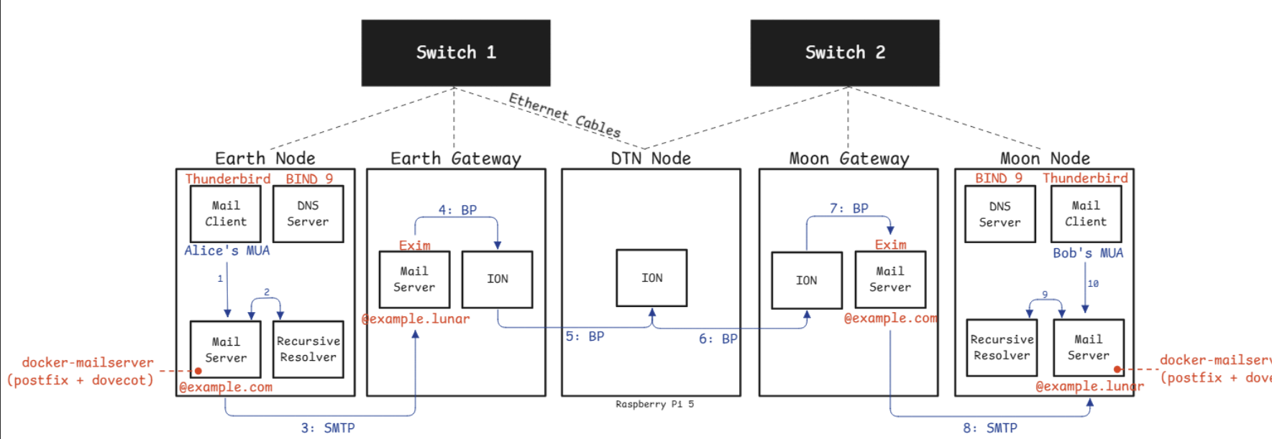

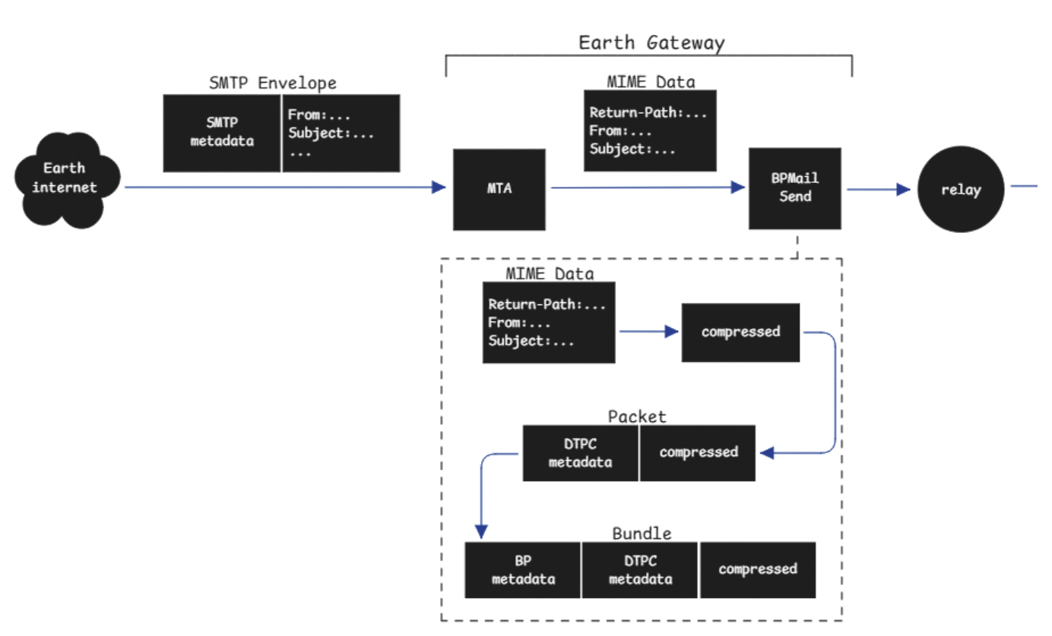

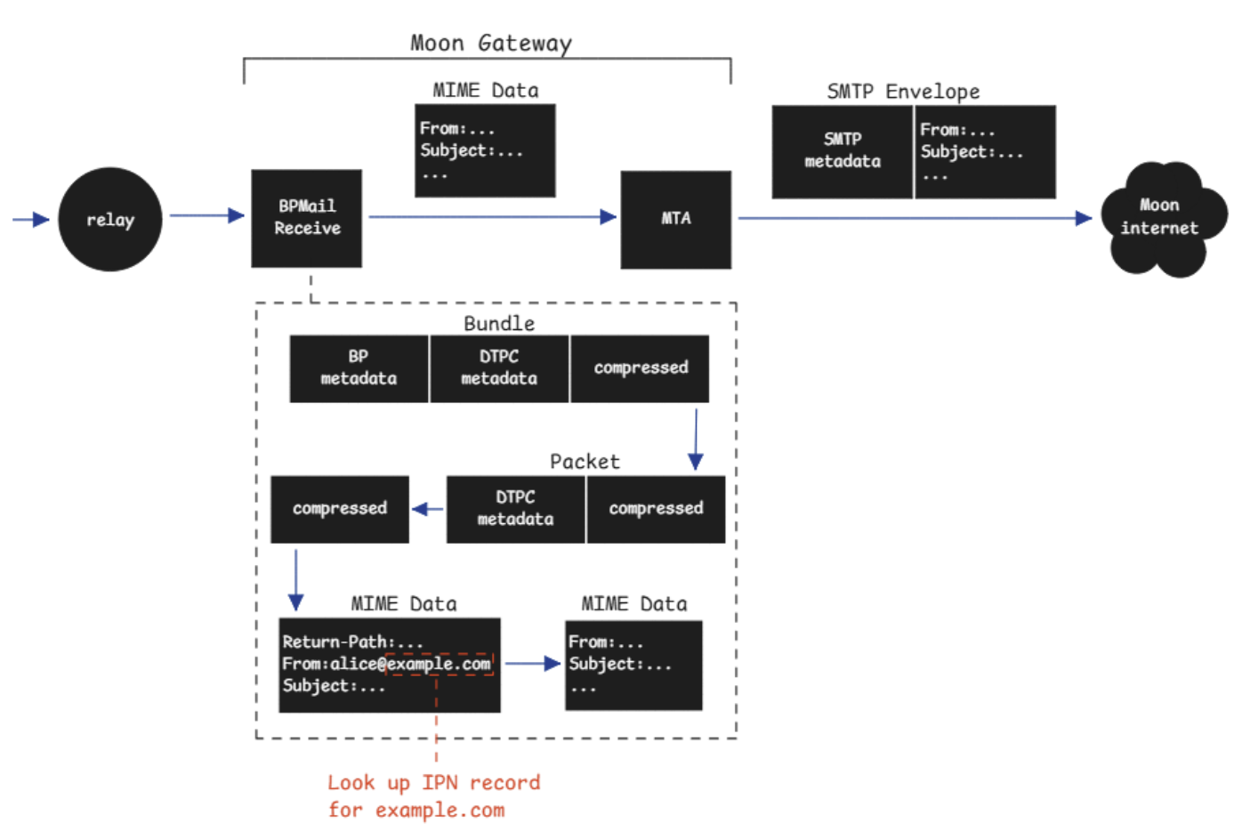

My implementation

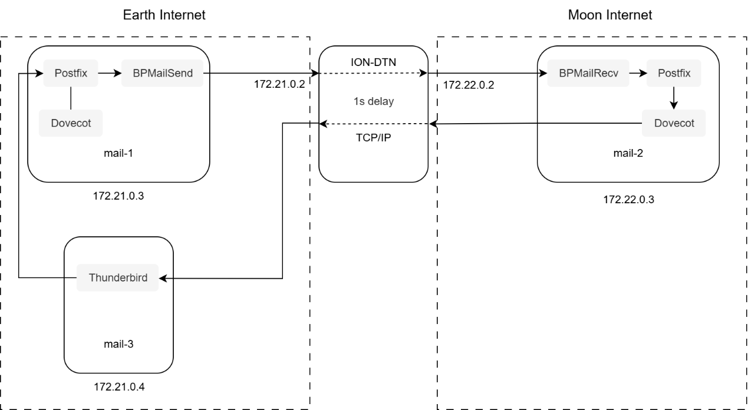

Deep Space Email Retrieval Delay Performance Experiment

Background

Johnson’s solution (draft-johnson-dtn-interplanetary-smtp) and the *SMTP Gatewaying Across Delay Tolerant Networks* project have reduced the impact of interplanetary delay and disruption on email delivery. They efficiently deliver SMTP emails via DTN to mailbox on other planets.

However, problems arise when users travel to another planet and want to check their emails: their messages are still delivered to their original planet’s mailbox, but the process of retrieving emails is still performed using the traditional TCP-based IMAP protocol. Syncing mail folders and confirming each message are still greatly affected by the high interplanetary latency.

Scenario Description

First, 1,000 emails (Body: “Hello”) are sent to the mail-2 server on the Moon. It means the recipient on the Moon has already successfully received their emails on the lunar email server.

Later, the recipient travels to Earth and wants to check these emails there. So, the recipient uses the Thunderbird client on mail-3 to retrieve these new emails via the IMAP protocol.

I test different physical one-way network delays (0s/1s/2s/5s), and record the total time required to retrieve all emails (overall retrieval time). The results are shown in the following table.

|  |  |  |  |
| --- | --- | --- | --- |
| Body | number of emails | Delay | overall retrieval time |
| Hello | 1000 | 0s | 19s |
| Hello | 1000 | 1s | 33s |
| Hello | 1000 | 2s | 64s |
| Hello | 1000 | 5s | 153s |

Findings

The overall download time increases linearly with network delay. When the delay is 5 seconds, the email client becomes very sluggish and is almost unusable.

To improve the email retrieval experience in deep space, it is necessary to introduce a DTN retrieval agent or a batch synchronization mechanism during the email retrieval process.